Diana L. Eck, Banaras City of Light
https://www.penguinrandomhouse.com/books/44788/banaras-by-diana-l-eck/

Istvan Keul, Banaras Revisited- Scholarly Pilgrimages to the City of Life
https://www.harrassowitz-verlag.de/Banaras_Revisited/title_210.ahtml

Eds. Martin Gaenszle and Jorg Gengnagel, Visualising Space in Banaras- Images, Maps and the Practice of Representation
https://www.harrassowitz-verlag.de/Visualizing_Space_in_Banaras/title_669.ahtml

Joyce Burkhalter Flueckiger, Material Acts in Everyday Hindu Worlds
https://sunypress.edu/Books/M/Material-Acts-in-Everyday-Hindu-Worlds

Kajri Jain, Gods in the Bazaar
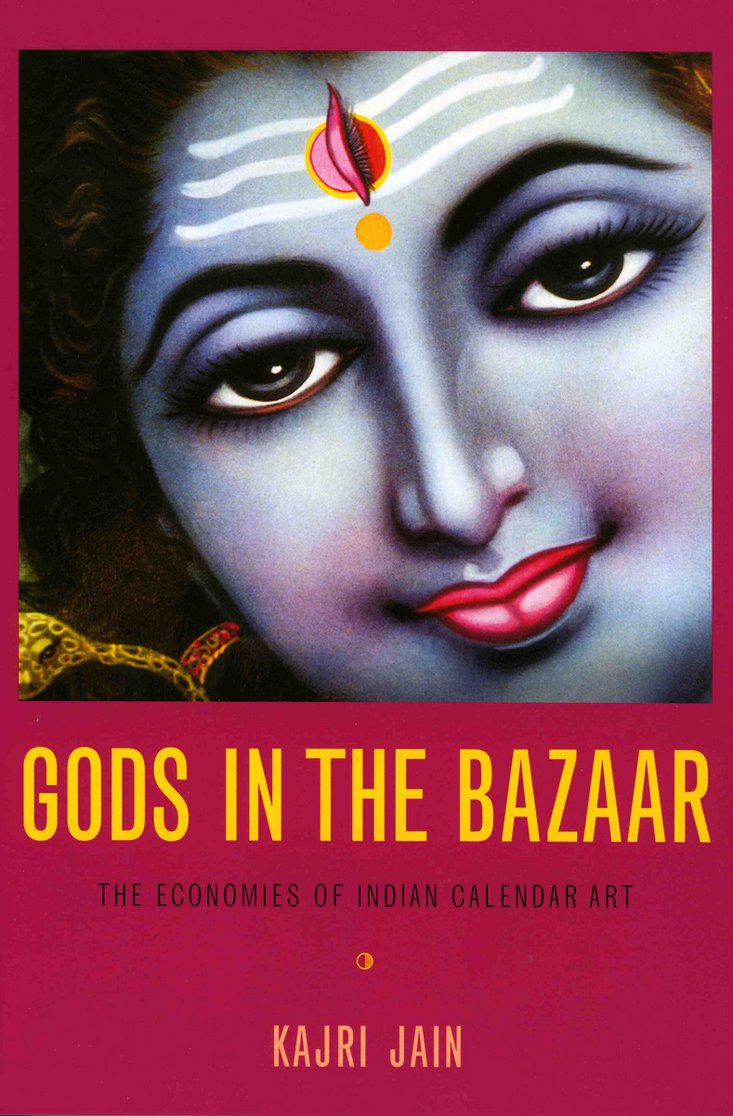https://dukeupress.edu/gods-in-the-bazaar

Kajri Jain, Gods in the Time of Democracy
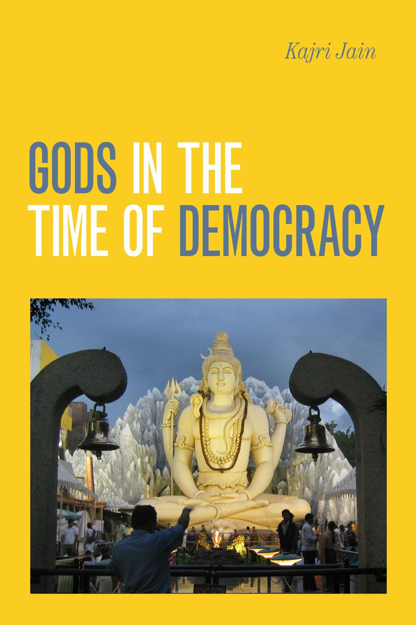https://www.dukeupress.edu/gods-in-the-time-of-democracy

Ed. Jyotindra Jain, India’s Popular Culture- Iconic Spaces and Fluid Images
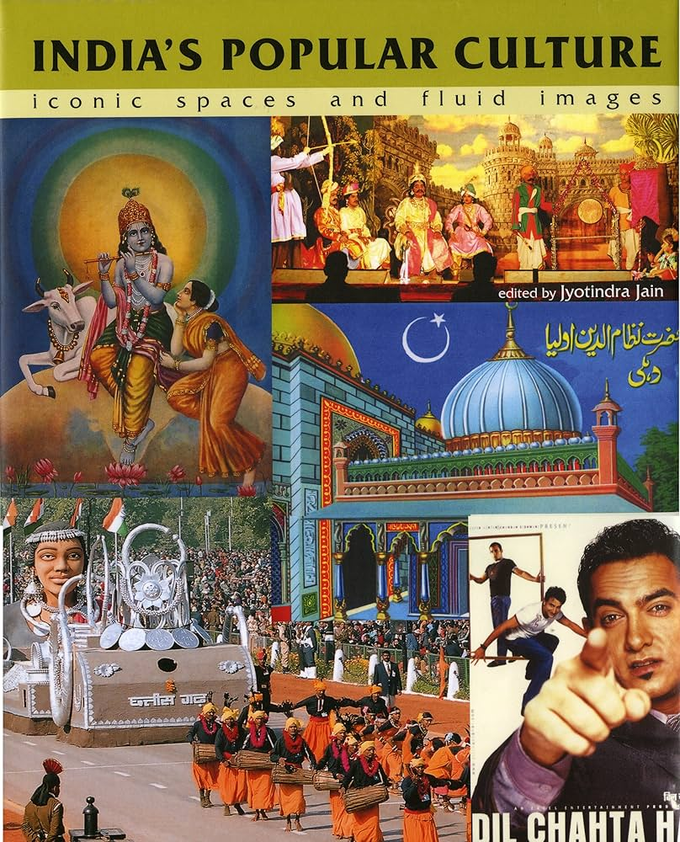https://marg-art.org/product/UHJvZHVjdDoyMzE2

Eds. Christophe Jaffrelot et al, Majoritarian State- How Hindu Nationalism is Changing India
https://academic-oup-com.uaccess.univie.ac.at/book/36682

Vasudha Dalmia, The Nationalization of Hindu Traditions- Bharatendu Harischandra and Nineteenth-Century Banaras
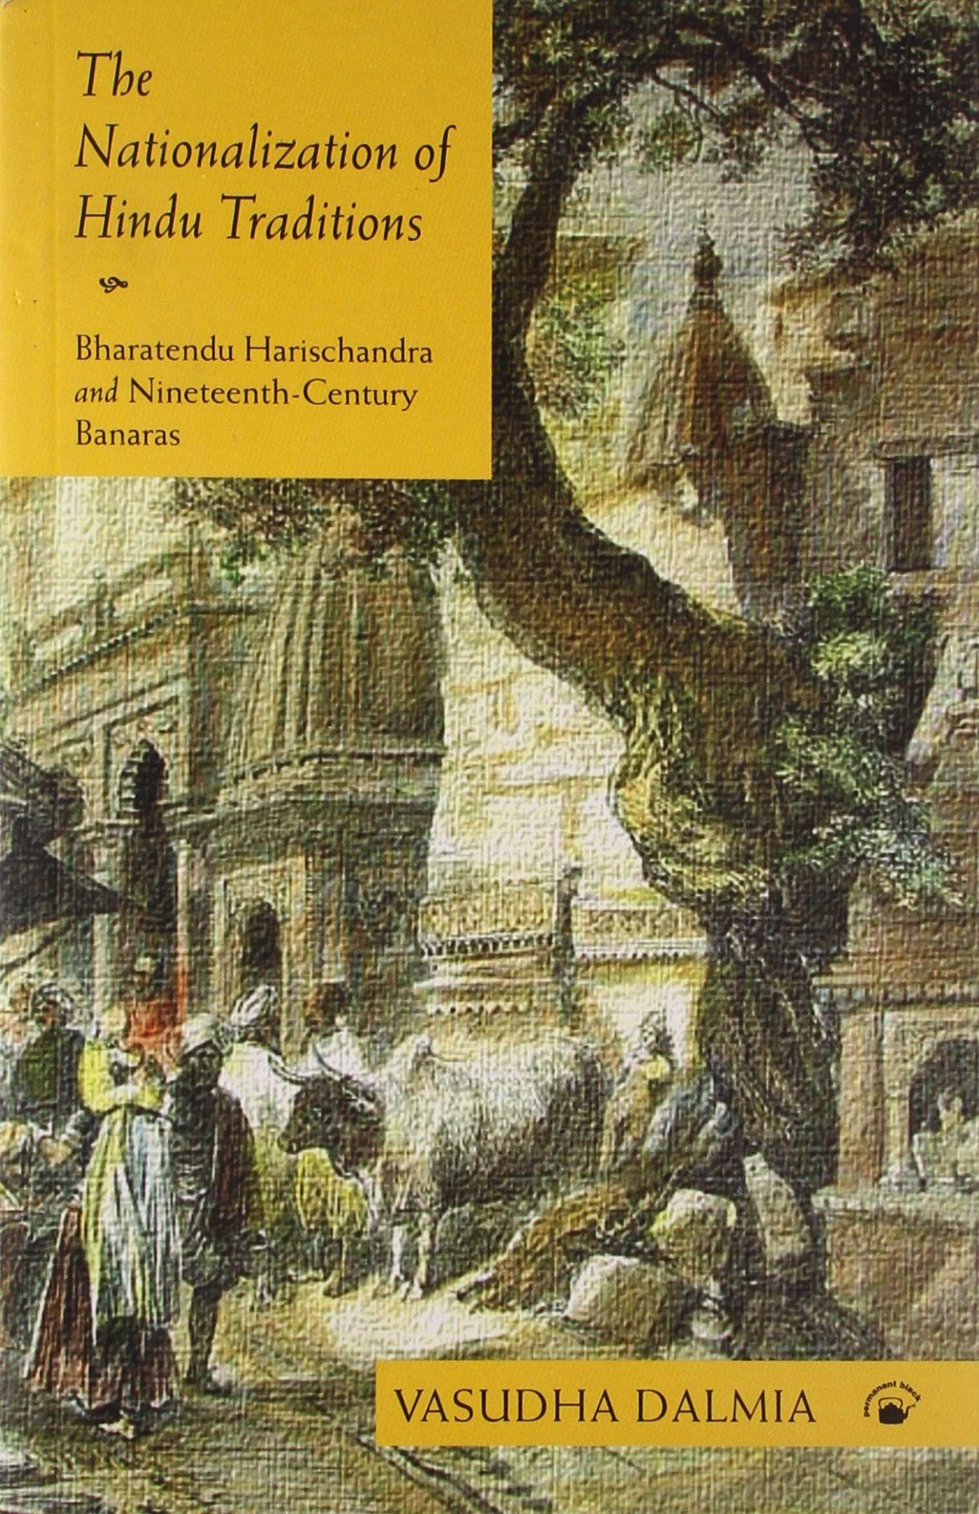
https://permanent-black.blogspot.com/2010/06/classic-monograph-reissued-with-new.html

Philip Lutgendorf, The Epic of Ram Volume 1
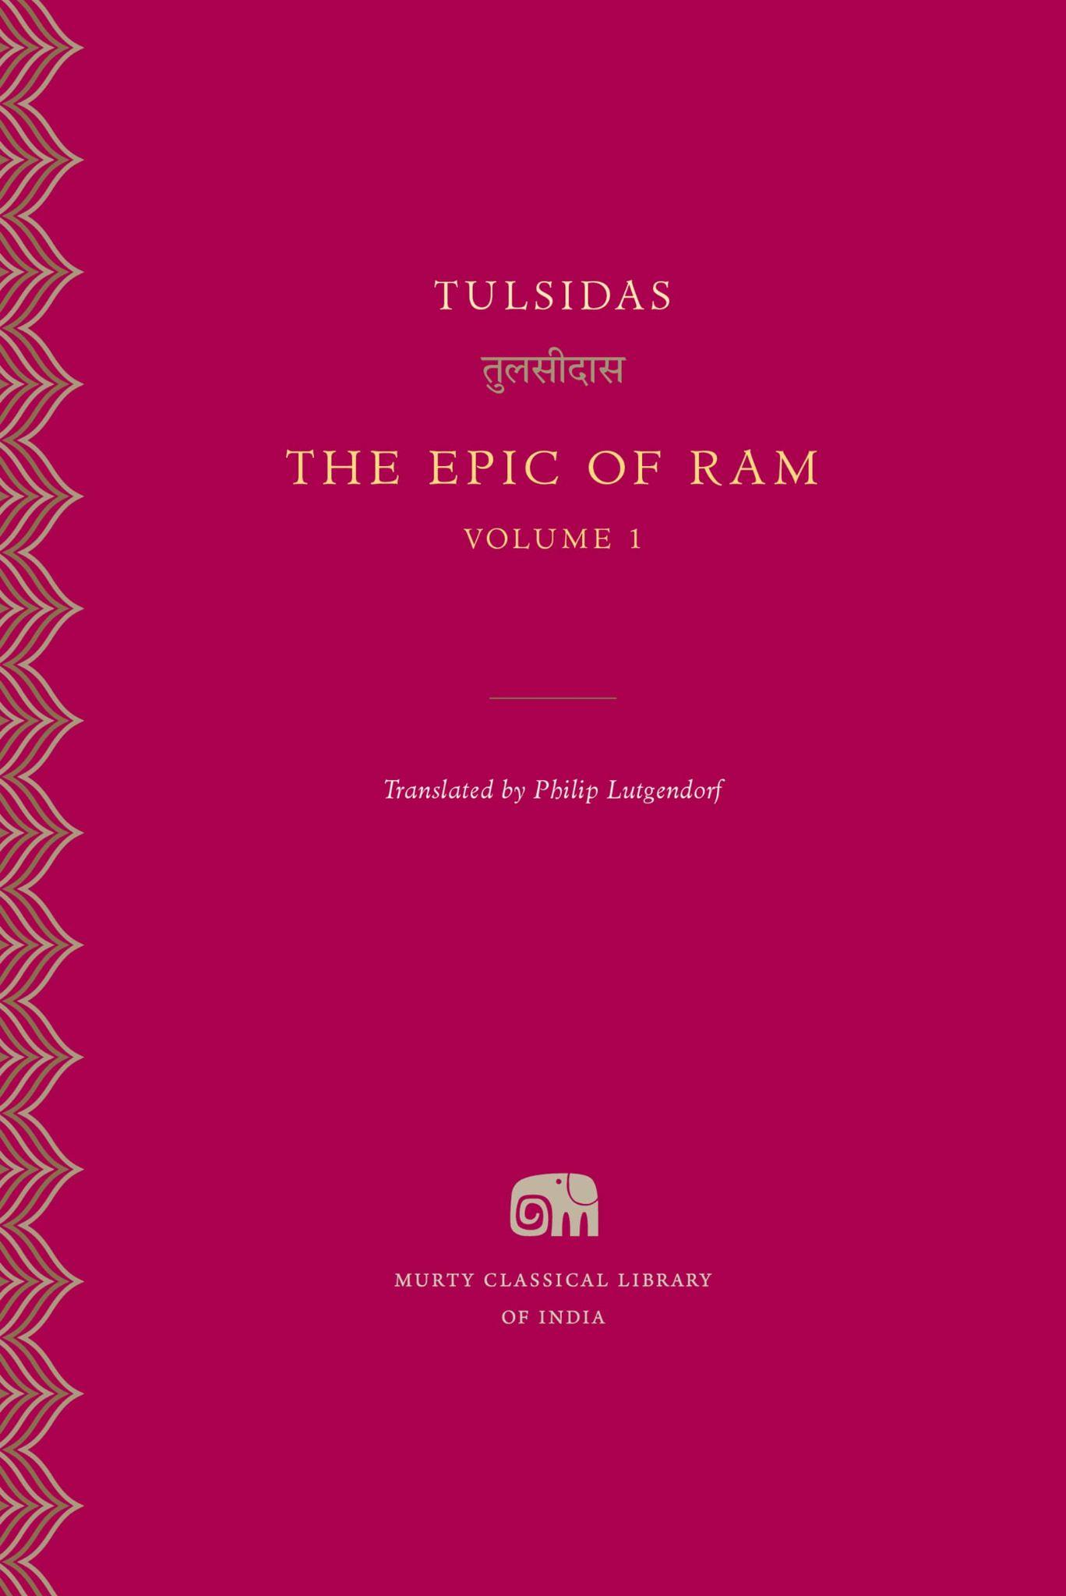https://www.murtylibrary.com/books/the-epic-of-ram-volume-1

Philip Lutgendorf, The Life of a Text- Performing the Ramcaritmanas of Tulsidas
https://www.ucpress.edu/books/the-life-of-a-text/hardcover

John Stratton Hawley, A storm of Songs- India and the Idea of the Bhakti Movement
https://www.hup.harvard.edu/books/9780674187467

Linda Hess and Shukdeo Singh, The Bijak of Kabir
https://www.mlbd.in/products/the-bijak-of-kabir-linda-hess-sukhdev-singh-9788120802162-8120802160?srsltid=AfmBOorOaRT9-b_8s3pN6ftTfEj1o-vwfE7g3uFcFqmpbSxpkfahZnI_

Linda Hess, Bodies of Song- Kabir Oral Traditions and Performative World in North India
https://global.oup.com/academic/product/bodies-of-song-9780199374175?cc=ru&lang=en&

Ed. by Xenia Zeiler, Digital Hinduism
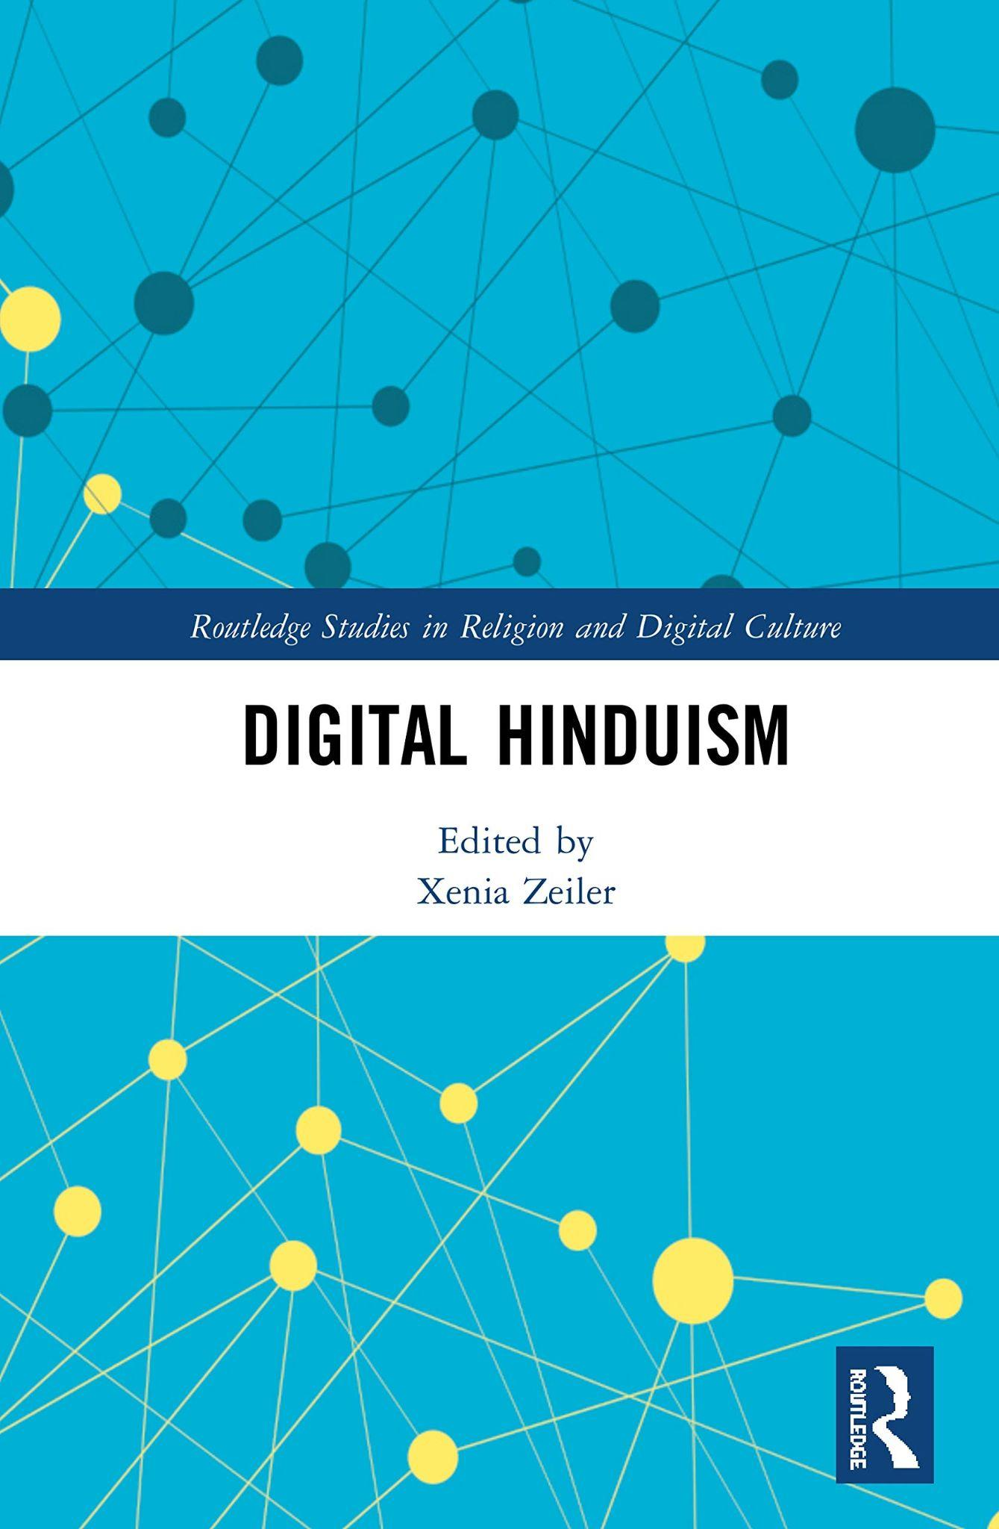https://www.routledge.com/Digital-Hinduism/Zeiler/p/book/9781032086484

